Netbones Solutions

“The Solutions Network”
183 Pagoda Rd,
Muizenberg
7948

hello@netbones.co.za
June 17, 2026,
TO: SORALIA HOMEOWNERS, C/O TRAFALGAR PROPERTY MANAGEMENT

A Vision for a Connected Soralia: Community Hub Proposal Version 2.0

For some months, ever since the idea was first mooted, I have been working on a project to address the challenges faced by our community.

As a software developer with a small ICT business “Netbones Solutions Pty Ltd”, I find myself uniquely situated to address the outlined proposal in a creative and innovative way.

The demonstration is already available and delivers everything that was proposed in version 1.0 of the previous proposal and a lot more too.

I certainly hope that you will participate in some of the preliminaries by circulating this document to all members and endorsing the proposal when it comes up for review at the next General Meeting.

The proposed resolution is also attached, as is a survey link which would assist the project.

Sincerely,

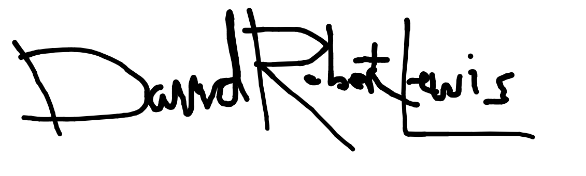

David Robert Lewis

183 Pagoda Road,
Soralia Village
082 425 1454

A Vision for a Connected Soralia:

Community Hub Proposal

Version 2.0

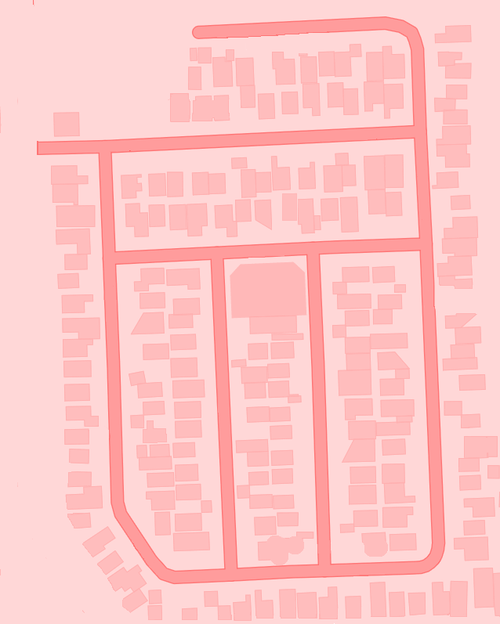

by David Robert Lewis
HOA member

June 2026

1. The Challenge: A Disconnected Community

Currently, our community numbers some 180-200 households comprising both tenants and homeowners. Members rely on several communication channels.

These include inter alia:

1.1 Official Email Communication from our Management Agents: Trafalgar

1.2 A billing related matters platform also run by Trafalgar, (formerly WeConnect via Residentia).

1.3. Telephonic communication that includes a circulated list of trustees numbers and the contact details of our management agents.

1.4. An official 'Soralia Village' Whatsapp Group, that has admin-only communication.

1.5. Unofficial Whatsapp groups such as "Soralians", that may be characterised as special interest or chat groups.

2. Analysis

Pending the outcome of the attached survey, whose data will be incorporated into a revised document. My interim analysis can be summarized as the following:

- Our Homeowners Association communicates in an ad-hoc and irregular fashion. We occasionally receive bulletins about Cape Nature, and speak at meetings.

- We receive annual reports, and emails, mostly about water disconnection events.

- The Whatsapp groups lack both document management and permanent history, and it serves Notices with the same priority as less formal communication.

- A major consideration for the Meta-owned Whatsapp platform is the lack of appropriate flags for Legal Notices versus important News items, with the result that a Notice about a matter related to a lost dog is given the same priority as a notice involving special legal attention.

- Finding a trusted local service, connecting with a neighbor who shares an interest, or accessing important HOA documents can be a challenge.

- Maintenance requests, emergencies involving water outages and the like are often handled in a piecemeal manner, we seem to roll from one emergency to the next without much preventative maintenance.

- There is a lack of periodic discussion on important issues affecting the community with the result annual meetings and occasional Special General Meetings are lengthy, often fruitless affairs.

- Maintenance itself is opaque, there is no way to book a service from the maintenance crew for valued-added benefits to the village and no dedicated Village liaison as such, aside from administrative billing and sparse management.

- There is currently no collective bargaining by HOA for valued-added services to the village and no inter-village liaison or cross-village activities.

- My general observation is that we suffer from scattered information, fragmented communication and word-of-mouth, that is 'lost-in-translation'.

In short: We lack a central, digital heart for Soralia

3. The Solution: A Central Hub for Every Resident

This proposal addresses the above problem statement ‘analysis’ via the development of a single, easy-to-use web application and integrated mobile app that brings everything Soralia into one place.

Initially, the project outline suggested a simple public facing directory.

But this isn't just a directory of homeowners and residents; it is a comprehensive Community & Resource Hub designed for modern living.

The site need not supplant other channels, but rather integrates and augments pre-existing communication, to provide a coherent data narrative that has permanence and institutional memory.

At its heart is a modern Content Management System (CMS) & Ticket Management System (TMS) that acts to store communication, documentation, and solutions unique to our community, whilst handling and channeling communication to those who need it.

A place to store specifications related to our geysers, the correct paint color codes, architectural & engineering plans, and also capable of processing maintenance requests and enabling communication amongst Homeowners and Residents alike.

A place where the community is allowed to express itself via special interest groups and affinity badges.

A place where Trustees and managers need not feel they are inundated with requests, but rather able to delegate, automate and serve coherent information.

Further, the platform should enable a range of services previously not available, whether services provided by members of the community or trusted third party services curated by the HOA.

In addition, since our community is diverse, we should handle localisation and support for languages other than English, with the aim of catering to at minimum, Afrikaans, Xhosa, Zulu.

The underlying architecture of the platform immediately suggests a modular approach, capable of growing and adapting to a living, breathing community.

The result from the perspective of Netbones Solutions, is a customisable, informatics platform. One that is currently being built by myself and the developers at Netbones Solutions, using the latest secure and scalable technology, that will ensure a UI/UX that is both powerful and easy to use.

4. Welcome to Soralia Village Online

Soralia Village Online is a mobile friendly web app. Think of it as a digital village square, a secure place where you can connect with neighbours, book the common room, access important documents, report a leak, join a book club, see what's happening, and have a say in community decisions. No Facebook groups, no WhatsApp chaos, no lost PDFs. Everything lives in one organised hub.

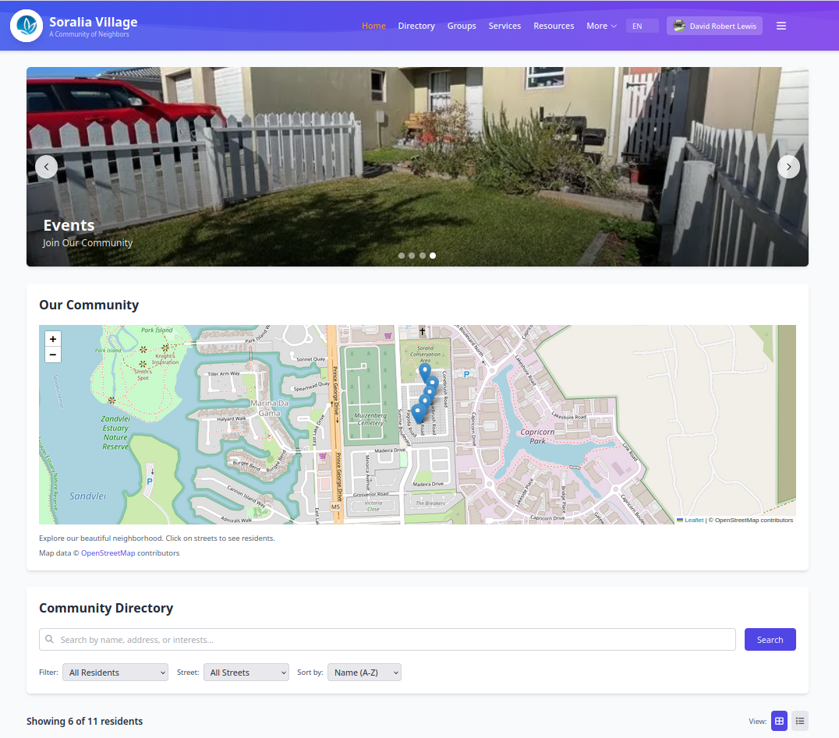

4.1 Your Personal Dashboard

When you log in, you land on your dashboard. This is your command centre. You can add, remove, quicklinks, and on the community space, add widgets like little cards on a pinboard — put what matters to you front and centre:

- Quick Actions — Report a maintenance issue, schedule a braai, message a neighbour

- Recent Activity — See what's happened since you last logged in

- Upcoming Events — Next committee meeting, weekend market, gardening club

- Your Notifications — Unread messages, booking confirmations, survey invitations

- Weather — Local forecast at a glance

You decide what your dashboard space looks like. Drag and drop to suit.

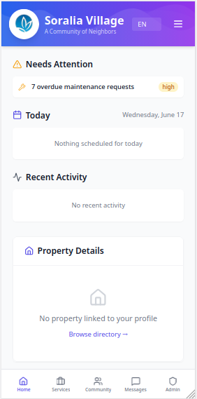

4.3 Spaces

The platform is organised into five Spaces that group related things together:

Home
Your dashboard. The place you start from. One glance and you know what needs your attention.

Services
All the practical stuff:

- Maintenance Requests — Got a leaky tap or a busted gate? Submit a request, attach a photo, choose the priority, and track it from "submitted" to "in progress" to "done." No more chasing the HOA via email.

- Facility Bookings — Need a nearby pool, gym, tennis court, or community centre? Check availability on the calendar and book your slot. No double-bookings, no confusion.

- Community Services — Need a plumber, electrician, dog walker, or tutor? Find neighbours who offer services, see reviews and ratings, and get in touch directly.

- Surveys & Polls — The HOA wants feedback on the budget for next year? A new security measure? A community event? Vote or answer in a few clicks.

- Competitions — Enter the monthly garden competition, photography contest, or braai master challenge. Celebrate your neighbours' talents.

Community
The heart of Soralia:

- Resident Directory — A searchable list of your neighbours. Filter by name, street, or shared interests. Each profile shows what you choose to share — your name, contact details, hobbies, or just a friendly wave. Privacy is entirely in your hands
.
- Resident Profiles — Each resident has a unique profile where they can publish content, create media, customise and express themselves.

- Interest Groups — Join or start a group: Hikers, Gardeners, Book Club, Mahjong, Running Club, Parents of Toddlers, you name it. Share posts, plan meetups, build real friendships.

- News & Announcements — Official HOA notices, committee updates, and community news in one trusted feed. No more scrolling through WhatsApp to find the important stuff.

- Events — A community calendar with everything happening in Soralia: yoga in the park, AGM reminders, weekend markets, holiday parties. RSVP right from the page.

- Media Gallery — Photos from events, albums shared by neighbours, a collective memory book for our village.

- Resources & Library — Community documents, guidelines, floor plans, welcoming packs — all in one digital bookshelf.

- Community Map — See where your neighbours live (who have chosen to be visible) on an interactive map of the estate.

- Proudly Soralia — A showcase of what makes our community special: resident spotlights, achievements, and stories.

- Campaigns — Whether you are running a conservation or cleanup campaign, it's all included.

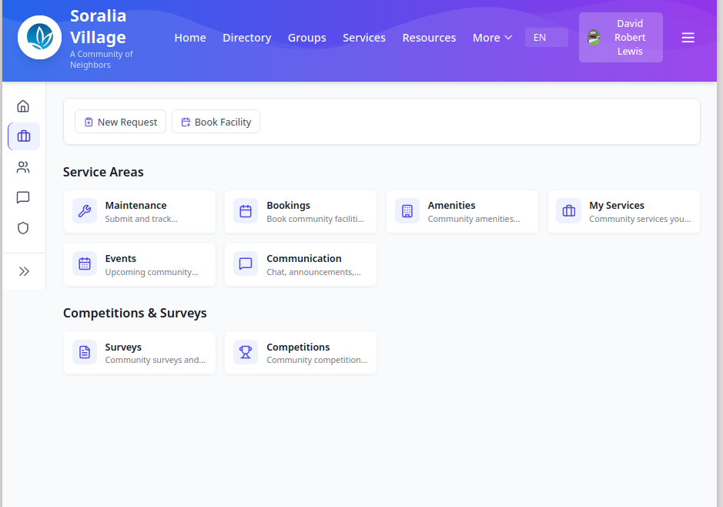

💬 Messages
Real-time chat, right in the platform:

- Direct Messages — One-on-one conversations with neighbours

- Group Chats — For your book club, committee, or street WhatsApp replacement

- Announcements — Broadcast messages from the HOA board

- Notifications — Get pinged when someone messages you, a booking is confirmed, or a maintenance job is marked complete

You can see when someone is online, when they're typing, and whether they've read your message. Everything stays inside the community — no phone numbers exchanged.

Admin (Board & Committee Only)
For the HOA board and committee members:

User Management — Invite new residents, manage accounts, allocate seats

Content Management — Write news articles, create announcements, publish events with the built-in editor

Maintenance Queue — View all open requests, assign teams, update residents on progress

Surveys Builder — Create polls and official votes with drag-and-drop question types

Booking Oversight — View and manage facility bookings or codesharing arrangements.

Reports & Analytics — See which features are being used, track response times, understand the community's pulse

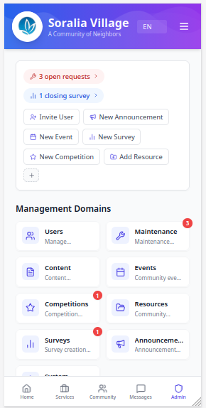

4.4 How You Belong: Seat Types

Not everyone in Soralia is in the same situation, so we have different seat types:

Seat | Who It's For | What You Get | Profile
Standard | Homeowners (one per household) | Full platform access, manage your household profile | Family members (up to 5 per home), groups, messaging — connected to the household
Solo | Independent residents (renters, singles) | Full platform access, your own identity or vanity address | Personal profile distinct from any property
Premium | Investors with one or more properties | All of the above plus a unified portfolio dashboard with agent access | Letting, or Selling, its all included.

4.5 Your Privacy, Your Rules

- You decide if your profile appears in the directory

- You decide if your email or phone number is visible

- You decide what interests to share

- You can message someone directly — or not. No pressure.

5. dWallet (Future)

Critical for the sustainability and long-term functioning of the system will be a means by which users can pay for services and track and own content that earns rewards.

Every user of the platform will be issued a dWallet (digital wallet) alongside a unique address that securely stores user payment info and any on-device digital assets.

dWallet acts as a secure, self-custodial, digital safe for signing, managing, authenticating, and exchanging digital assets, documents, and credentials on the platform ecosystem.

This enables users to earn rewards from filling out surveys, to pay for services from their rewards balance, and to transact when they use the Services directory.

More significantly it enables users to also receive any platform profit-sharing revenue that may be due according to the pending schedule and the proposed SaaS agreement to be signed between the platform operator and HOA.

6. Why Adopt This?

What you have today:

Scattered WhatsApp groups for different topics

Email chains that bury important information

Ad hoc arrangements for bookings and maintenance

No central calendar or directory

Hard to know who your neighbours are and what they're interested in

Difficult to access critical documents, reports and architectural guidelines.

6.1 What this platform gives you:

One place for everything, accessible from your phone or computer

No more chasing — submit a request and track it yourself

Real community connection — find neighbours who share your interests

Informed decision-making — surveys and votes reach everyone, not just those who show up

Transparency — see what the HOA is working on and what's been completed

Privacy you control — you decide what to share and with whom

7. Key Benefits for Every Resident

Enhance Connection: Easily find and connect with your neighbors.

Improve Accessibility: Access a curated list of trusted services anytime.

Centralize Information: Stop hunting for information. Find everything you need in one place.

Empower Residents: Manage your own household profile, control your privacy, and contribute to the community knowledge base.

Empower the HOA and Management: Enable portfolio managers to more easily manage their portfolios.

Express yourself: Generate content, communicate and participate.

8. The Path Forward

The attached model resolution is the first official step.

By voting YES, we authorize the HOA Board to negotiate and formalize an agreement with Netbones Solutions Pty Ltd in order to begin the development and customisation process that will turn this vision into a valuable asset for our entire community.

Providing your endorsement will authorise HOA to express their interest and for Netbones to make available the draft SaaS Agreement and Schedules, to be completed at the discretion of the trustees.

Resolution of the Soralia Homeowners Association

Adoption of the Proposal for a Community Directory and Resource Hub

Date of Meeting:

Resolution Number:

Subject: Adoption of the Proposal for a Village Website Directory and Resource Hub

WHEREAS, the Soralia Homeowners Association (HOA) has identified a critical need for a modern, centralized digital platform to enhance community connection, improve service accessibility, and provide a single source of truth for important information for all residents;

WHEREAS the lack of such a platform currently presents challenges in communication, information sharing, and the efficient discovery of community and resident-offered services;

WHEREAS, the HOA Steering Committee/Trustees have received, reviewed, and endorsed a comprehensive proposal from Netbones Solutions Pty Ltd, titled "Project Proposal: Soralia Village Home-Owner's Association (HOA) - Community Directory & Resource Hub" (Version 2.0, dated 17 June 2026), hereinafter referred to as "the Proposal";

WHEREAS, the Proposal outlines a robust, scalable, and secure solution for a Community Directory and Resource Hub, detailing the project's vision, architecture, core features, development methodology, and implementation plan;

NOW, THEREFORE, BE IT RESOLVED THAT:

1. The Soralia Homeowners Association hereby formally adopts the plan and solution detailed in the Proposal to develop and implement a "Community Directory and Resource Hub."

2. The HOA Steering Committee/Trustees are hereby authorized and directed to proceed with the next steps as outlined in the Proposal, which include finalizing a formal agreement with Netbones Solutions Pty Ltd.

3. The Steering Committee/Trustees are further authorized to negotiate and approve the final project contract, timelines, and budget on behalf of the Soralia Homeowners Association, and to allocate the necessary funds for the successful execution and delivery of the project.

Moved by: _________________________

Seconded by: _________________________

Vote:

For: ______
Against: ______
Abstain: ______

Result: The resolution is hereby PASSED / FAILED

Certified by:

_________________________
(Name), (Title, e.g., Chairperson/Secretary)
Soralia Homeowners Association

